M/s. Fidelity – MY Banger - PA (H&M)

ULA reference: 251234 – 1v1
Applicant’s Name: M/s. Fidelity Assurance & Reinsurance Co. S.A.L.
Assured’s Name: Miss Rema Anis Youssef
Policy No.: MAB-5023262-01-00
17 March 2026


It’s about time you receive the quality of service and expertise your firm deserves.
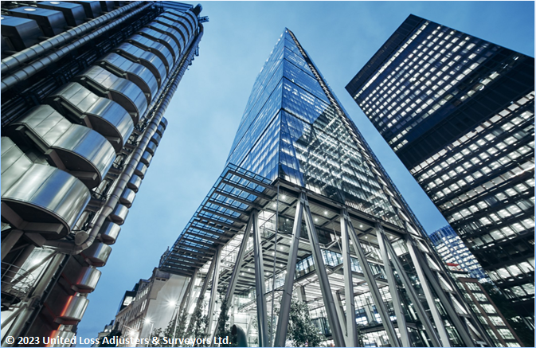

Document Control Page
Investigated by: | Reviewed by: | Approved by:
Feyez Dghaily | Petro Zaarour | Petro Zaarour
Designation: | Designation: | Designation:
Technical Specialist | Chartered Engineer & Average Adjuster | Chartered Engineer & Average Adjuster
Signature (Approver)
This survey and its issued report were completed without prejudice to all rights of parties concerned and its concluded adjustment is in accordance with the relevant insurance policies.
Date of approval
17 March 2026

Version history | Date of issue | Reason for Revision
1 | 17 March 2026 | Final Issue
The contents of this report are for the confidential information of the client
This survey and its issued report were completed without prejudice to all rights of parties concerned and its concluded adjustment is in accordance with the terms and conditions of the relevant insurance policy.
Report and adjustment note
At the request of M/s. Fidelity Assurance & Reinsurance Co. S.A.L. (the Insurer), the correspondent Surveyor to ULA was tasked to review a particular average (PA) claim for Miss. Rema Anis Youssef (Assured/Yacht Owner/ Policy Holder) claiming on their policy of Marine Insurance no. MAB-5017454-06-00, quantify the extent of the damage and validate the claim on the subject policy. Table 1 is a summary with details pertaining to this claim.
Table 1 - Summary and salient details (MY BANGER – POL000KUE)
Miss Rema Anis Youssef - ULA Reference 250430
Insurance Policy | MAB-5023262-01-00– Marine Leisure Boats
Basis of Coverage | - Institute Yacht Clauses Cl. 328 dated 1/11/85  - Institute Yacht Clauses – Machinery Damage – USD 500,000  Extension Clause Cl. 332 dated 1/11/85 (deductible USD 2,500.00) for each and every loss  - Institute Yacht Clauses – Personal Effects Clauses (USD 3,000)  Cl. 331 dated 1/11/85 (deductible USD 250 for each & every loss)  - General Third-Party Liability Aggregate Limit (USD 500,000.00)
Yacht’s Name /Home port | MY BANGER (Marina Dbayeh)
Engine specifications | Volvo Penta
Registration Number | POL000KUE
Claim circumstances | Malfunction of the Active Corrosion Protection (ACP) system
PA occurrence date | 17 January 2025
Date of attendances | 17 January 2025 at Dawra Marina
Policy Law & Jurisdiction | This insurance shall be governed by and construed in accordance with the law of Lebanon and each party agrees to submit exclusive jurisdiction to the Courts of Lebanon.
Practice | English – AAA Rules 2020

INTEREST INSURED & RELEVANT CONDITIONS OF INSURANCE POLICIES
The insured M/Y BANGER is a motor yacht, built in 2013. Equipped with two Volvo Penta engines, each rated at 600 horsepower. The basis of policy coverage is the Institute Yacht Clauses, Cl. 328, dated 1/11/85, with a sum insured of USD 500,000. Cover is also extended to Institute Yacht Machinery Extension Clause Cl. 332 dated 1/11/85 (deductible USD 2,500.00) for each and every loss.

ADJUSTER NOTES
On 16 January 2026, while the yacht remained in dry dock for the inspection and repair of the ACP system, the Assured submitted a new PA claim relating to the propulsion system. This was following the discovery of a nylon bag stuck within the starboard propeller during the yacht’s bottom inspection by the correspondent Surveyor and the Assured at the Dawra Marina, Lebanon. The following observations were noted:
- A nylon bag was found lodged between the propellers of the starboard IPS pod.
- Inspection of the pod lubricating oil revealed water contamination, indicating damage to the main propeller shaft carrier kit seal caused by the nylon bag.

CAUSE OF DAMAGE
Propulsion System / Seal Kit Damage
The proximate cause of damage to the main propeller shaft seal kit on the starboard IPS propulsion unit is a nylon bag trapped between the propeller blades. This foreign object induced uneven loading on the mechanical lip seal, which is engineered to prevent ingress of water and oil along the rotating shaft. This resulted in localised deformation and abrasive wear along the inner sealing lip, compromising the seal’s integrity and allowing water to contaminate the lubricating oil. The contaminated oil lost viscosity and reduced its protective properties, subjecting the supporting bearings and rotating shaft to elevated friction, accelerating wear on internal gears and diminishing the overall operational lifespan of the propulsion unit.
The damage is consistent with the perils of the seas, encompassing foreign object intrusion and hydrodynamic forces experienced during normal vessel operation, which directly contributed to the mechanical compromise of the seal.

CONCLUDED CLAIM QUANTUM & ADJUSTMENT
Based on replacement and repair invoices No. 01/26 dated 27 January 2026 (copy attached), covering all repair works for the IPS unit carrier seal, associated shaft and propeller repairs, and related labor, the claim has been assessed and adjusted in accordance with the updated Table 2.
The costs included are directly related to the damage caused by the compromised IPS unit carrier seal as a result of the accidental nylon bag lodged between the propellers, which resulted in water contamination of the oil. These costs cover:
- Replacement of the damaged carrier seal.
- Repair or replacement of any mechanical components associated with the main propeller shaft.
- Labor required for the removal, reinstallation, and proper adjustment of the unit.
All invoiced amounts reflect costs that are reasonable, necessary, and directly arising from the proximate cause of damage. Costs not directly linked to the insured incident, or that constitute routine consumables or have been previously claimed, have been excluded. These were interpreted in accordance with the latest set of Rules of Association of Average Adjusters as a guiding principle.
Table 2 – Presented claim and adjustment
Description | Qty. | Unit Price  USD | Total Price  USD | Reasonable/Covered | Notes
Platform job
Renovation seal kit for both hydraulic piston | 2 | 870.00 | 1740.00 | No / No | Damage unrelated to propulsion system
Manufacturing new main support stainless | 2 | 146.00 | 292.00 | No / No | Structural damage unrelated to propulsion system
Telescopic crane to remove tender and platform | 1 | 180.00 | 180.00 | No / No | Access to the platform, not related to propulsion
Stainless screw for main support | 8 | 9.00 | 72.00 | No / No | Not linked to IPS damage
Crane to install back the platform | 1 | 180.00 | 180.00 | No / No | Not linked to IPS damage
Swimming ladder
Stainless job fixing and welding, changing main screw, manufacturing washer spacer | 1 | 180.00 | 180.00 | No / No | Not related to propulsion damage
Stainless pieces for adjusting swimming ladder | 1 | 95.00 | 95.00 | No / No | Not linked to propulsion system
Manufacturing new spacer washer | 4 | 45.00 | 180.00 | No / No | Not linked to propulsion system
Labor for removing platform, removing hydraulic piston, swimming ladder job renovation job, installing and adjusting platform | 1 | 1800.00 | 1800.00 | No / No | Unrelated to IPS damage
Dry dock services | 1 | 150.00 | 150.00 | Yes / No | (Costs already recoverable under first PA – See report 1)

IPS
Carrier seal kit for IPS | 1 | 1320.00 | 1320.00 | Yes/Yes | Directly caused by nylon bag lodged between propellers, compromising seal kit
Labor for removing propeller changing carrier kit, installing new parts with propeller Flushing product to clean IPS shaft, swimming ladder, all stainless of plat form | 2 | 550.00 | 1100.00 | 1 unit covered / 550.00 USD | Only labor for the starboard IPS pod seal replacement is covered; the second unit, unrelated to the damage, is excluded
Flushing product to clean IPS shaft, swimming ladder, all stainless of platform | 4 | 90.00 | 360.00 | Yes/Yes | Covered for IPS seal repair
Lock clamp for the main chain anchor | 2 | 85.00 | 170.00 | No / No | Not covered – not linked to propulsion system
Volvo Penta D11
Fuel filter | 2 | 149.00 | 298.00 | No / No | Not covered – engine maintenance unrelated to IPS
Oil filter long-life | 4 | 42.00 | 168.00 | No / No | Not covered – routine engine maintenance
Oil filter | 2 | 38.00 | 76.00 | No / No | Not covered – routine engine maintenance
Engine oil | 90L | 9.00 | 810.00 | No / No | Not covered – routine engine service
Belt | 2 | 89.00 | 178.00 | No / No | Not covered – routine engine maintenance
Water pump belt | 2 | 82.00 | 164.00 | No / No | Routine engine maintenance
Water fuel separator | 4 | 53.00 | 212.00 | No / No | Engine repair not related to IPS – No coverage
insert | 4 | 92.00 | 368.00 | No / No | Not linked to propulsion damage
Impeller kit | 2 | 108.00 | 216.00 | No / No | Engine system maintenance No coverage
Anode kit zinc | 8 | 22.00 | 176.00 | Yes/No | (Costs recoverable under First PA – See report 1)
Labor for engine services, cleaning and flushing | 2 | 250.00 | 500.00 | No / No | Routine engine service – Not covered
Flushing product for saltwater system in engine | 4 | 22.00 | 176.00 | No / No | Routine maintenance – No coverage
IPS system
Oil filter | 2 | 68.00 | 136.00 | 1 unit covered / 68.00 USD | Directly related to seal failure
Ips oil | 10 gal. | 268.00 | 2680.00 | 1 unit covered / 1340.00 USD | Directly related to seal failure
Labor for IPS servicing | 2 | 150.00 | 300.00 | 1 unit covered / 150.00 USD | Labor for routine IPS cleaning/service; not directly linked to repair of damaged seal kit
Anode | 2 | 168.00 | 336.00 | Yes/No | (Costs recoverable under First PA – See report 1)
Anode kit | 1 | 398.00 | 398.00 | Yes/No | (Costs recoverable under First PA – See report 1)
Generator
Oil filter | 1 | 42.00 | 42.00 | No /No | Routine service – No coverage
Fuel filter | 1 | 49.00 | 49.00 | No /No | Routine service – No coverage
Impeller kit | 1 | 95.00 | 95.00 | No /No | Routine maintenance – No coverage
Oil for generator | 6L | 9.00 | 54.00 | No /No | Routine maintenance – No coverage
Water fuel separator | 1 | 34.00 | 34.00 | No /No | Routine maintenance – No coverage
Labor for generator services | 1 | 150.00 | 150.00 | No /No | Routine maintenance – No coverage
Flushing product | 3 | 90.00 | 270.00 | No /No | Routine maintenance – No coverage
Initial Claim Amount ------------------------------------------------------------------------------------------------------ USD 3,788.00
Less Deductible (USD 2,500) for each and every loss-------------------------------------------------------------- USD 1,288.00
Say, US Dollars One Thousand Two Hundred Eighty-Eight only

CONCLUSION
In our opinion,
- The adjusted claim amount of USD 1,288 reflects costs directly related to the damage of the starboard IPS unit carrier seal caused by an accidental floating nylon bag lodged between the propeller blades, including the labor required to remove, replace, and properly reinstall and adjust the affected components, and is considered fair and reasonable, subject to the terms, conditions, and applicable deductible of the policy;
- This is thought to have occurred within the period of the subject policy, within the insured navigation area;
- The damage is consistent with perils of the seas, as a foreign floating object at sea caused partial mechanical deformation and abrasion of the seal, allowing water contamination of the oil, increasing stress on the bearings and rotating shaft, and accelerating wear on internal components. As such, the claim should be recoverable under Clause ‘9.1.1 perils of the seas rivers lakes or other navigable waters ’ of CL 328 as damage consistent with accidental perils of the seas;
- Costs for routine maintenance, consumables, oil, and filters have been excluded, as they do not constitute direct insured damage under the policy terms;
- All invoiced amounts are reasonable, necessary, and arise directly from the proximate cause of loss, with no duplication of coverage for items previously admitted;
- In the absence of a liable third-party, a claim recovery is thought to be unlikely;
- There is no evidence to suggest underinsurance at the time of damage.
We confirm the sighting of original documents (as made available to report), pertaining to a claim of this nature.
End of report and adjustment note
Claim supporting documents
Enclosed Documents:
- Insurance Policy No. MAB-5023262-01-00
- Invoice No. 01/26
- Inspection Report
- Receipt
- Quotations

Appendix A – Photograph Taken During Inspection
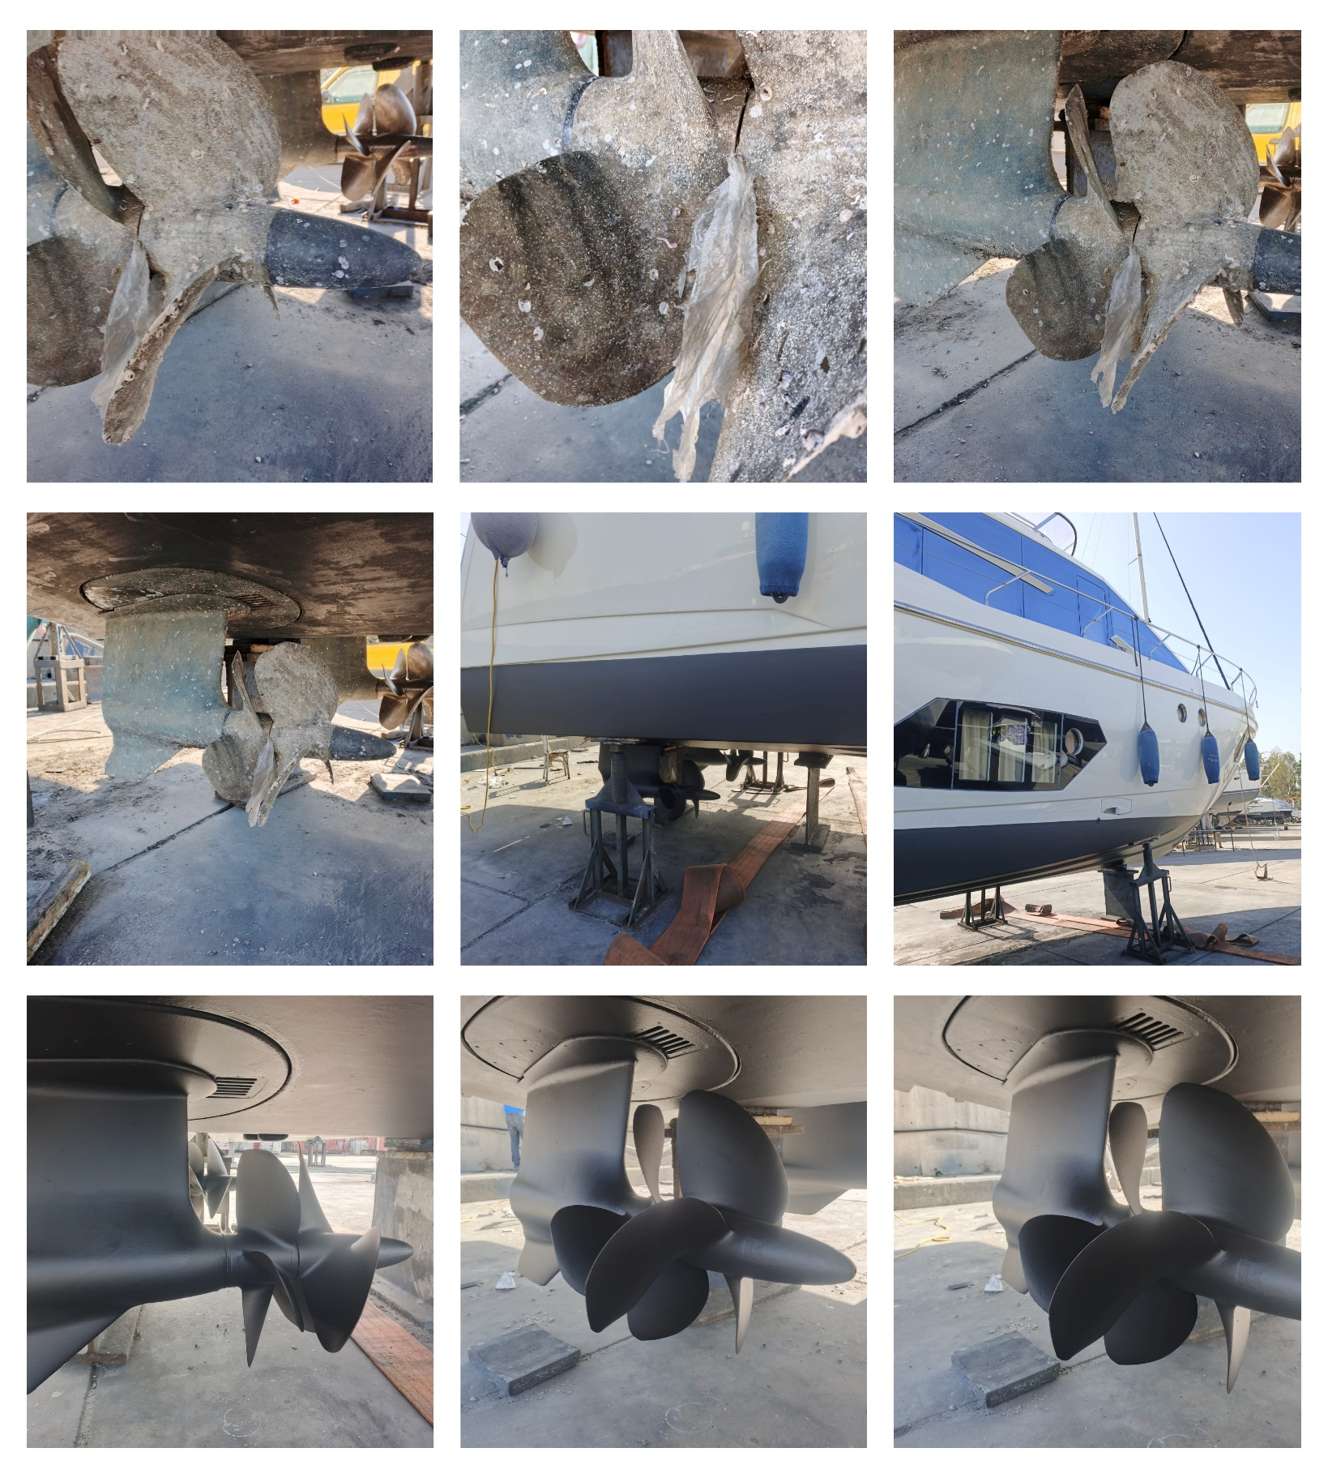
About ULA
United Loss Adjusters and Surveyors (ULA) is a leading international provider of Adjusters, Surveyors, Solicitors, and Consultants, offering unrivalled technical and legal solutions with exclusive access to the London Market's leading specialists.
Founded in 2002, with strategic head offices in the Middle East and the United Kingdom, today ULA is the strategic ally of a world leading legal firm (with offices in over 60 major countries) and the correspondent for a number of global technical service providers (with offices in 140+ countries), with principals including but not limited to Insurers, Reinsurers, Brokers, P&I clubs, Ship Owners, Shipyards and Agencies.
Lines of business:
- Insurance & Re-insurance
- Claims solutions and loss adjusting across all major lines: aviation, cargo, marine, property, fine arts, and special risks claims
- Cargo & Containers
- Marine & Offshore
- Global Claim Recoveries & Legal Support
Our team:
Our team of qualified professionals, experienced in the fields of Marine, Insurance, Finance, Engineering, and Law known and respected for their integrity and credibility. Supported by a highly mobile team strategically positioned where our services are needed, we are always available on short notice to deal promptly with your queries. ULA is independent to the core and can be trusted to express unbiased views, and is not influenced by stakeholders.
ULA’s team members are recognised:
- Chartered Engineers
- Consultants
- Inspectors & Auditors
- Insurance & Re-Insurance Underwriters
- Loss & Average Adjusters
- Master Mariners & Chief Engineers
- Naval Architects, Marine & Offshore Engineers
- Solicitors
- Sworn Surveyors
ULA’s team members are also recognised members of the following international institutions:
- The Association of Average Adjusters (AAA)
- The Bar Council of England and Wales
- The Chartered Insurance Institute (CII)
- The Chartered Institute of Loss Adjusters (CILA)
- The European Federation of Loss Adjusting Experts (FUEDI)
- The Institute of Fire Engineers (IFE)
- The Institute of Marine Engineering, Science and Technology (IMarEST)
- The UK Engineering Council
- The Royal Institute of Naval Architects (RINA)
- The International Institute of Marine Surveying (IIMS)
- The Royal Institute of Chartered Surveyors (RICS)

Contact person
P. Zaarour
Director
United Kingdom: 71-75 Shelton Street, Covent Garden | London, England - WC2H 9JQ
Middle East: Mina Tower, Ain Waraka Street | Beirut, Lebanon - WG2G+5CX

Registered name United Loss Adjusters & Surveyors Ltd.

24/7 Contacts & Claim Support – T: +44 (0) 20 3287 3326 | M/WhatsApp: +44 (0) 7 375 110 573
Office E: claims@unitedlossadjusters.com
W: https://www.unitedlossadjusters.com/



